Seatbelt / Beltminder Telltale – IPC Controlled C490 Specific GCEA 1.3
(Beltminder Buckle/Unbuckle Deactivation function disabled)

Functional Description

This STSS is C490 specific because C490 uses PDS instead of occupant weight sensor wired in series with the passenger buckle switch. Because of this, between 7s and 37s after key on if the passenger seat PDS is activated and deactivated due to occupant movement in the seat the IPC receives FirstRowBucklePsngr signal state changes between belted and unbelted. This has been shown to inadvertently disable or enable the beltminder feature. Due to this the Programming_Timer variable is being changed from 30s to 0s to disable the beltminder buckle enable/disable function for this program only. Other programs which use the PDS instead of the occupant weight sensor may also need to implement this STSS. Upon agreement of long term solution the generic Seatbelt/Beltminder STSS may be updated.

The purpose of the Seatbelt / Beltminder Warning feature is to alert the driver that his/her seat belt is not fastened.

The Seatbelt Beltminder Telltale correlates the FirstRowBuckleDriver signal, FirstRowBucklePsgr signal, FirstRowBuckleMid signal, PsngrFrntDetect_D_Actl signal, PsngrFmidDetect_D_Actl signal, Veh_VActlEng signal, GearLvrPos_D_Actl signal (automatic transmission) or GearRvrse_D_Actl (manual transmission), and the Operational_Mode to illuminate, flash, or extinguish the Seatbelt_Telltale and sound the associated audible warning.

The Seatbelt / Beltminder Telltale shall provide an iconic representation that will illuminate or flash to inform the driver that the driver or the driver/front passenger(s) seatbelts are not buckled. The telltale shall extinguish upon buckling the seat belt(s) which activated the telltale. The seatbelt warning shall consist of an initial warning period followed by the beltminder warning. The initial warning shall complete prior to the beltminder warning becoming active. Upon completion of the initial warning period and prior to the beltminder becoming active the seatbelt warning indicator shall flash to confirm enable/disable of the beltminder feature.

The primary purpose of the initial warning period is to meet the requirements of FMVSS relative to seatbelt telltale and chime. There is an intentional separation period between the initial warning and the beltminder warning to insure there is a clear indication the regulated warning has completed prior to the beltminder warning beginning. The initial warning is also set to 65 seconds to insure the regulated minimum FMVSS warning time of 60 seconds is met.

For markets where ECE Reg 16 must be met, or NCAP points must be achieved, the FoE Seatbelt Warn Strat config is enabled. The initial warning period is set to 5s and the initial chime timer is set to 0s to disable the FMVSS seatbelt chime. This provides for 5s seatbelt telltale ON period after which the seatbelt telltale turns off. After the 5s initial warning period as soon as vehicle speed is greater than 20km/h the first beltminder event will occur. For this configuration each beltminder events occur every 9.5s until time out.

Interfaces

Interface Context Diagram (I/O Block Diagram)
Figure 1 Seatbelt Beltminder Telltale Context Diagram
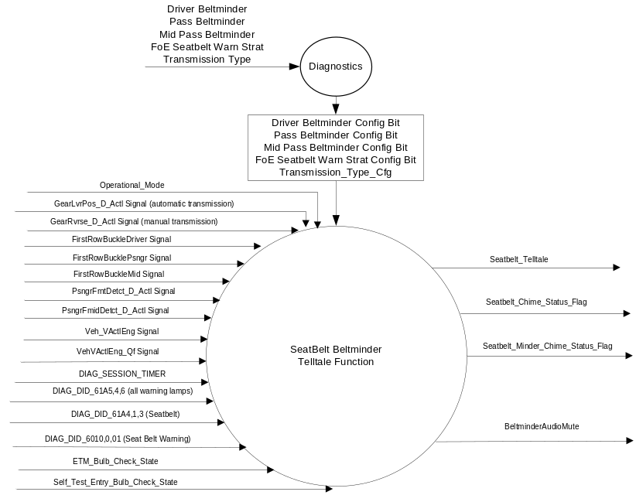

Inputs
      - INTERNAL:
            - DIAG_SESSION_TIMER
            - Operational_Mode
            - Driver Beltminder Config Bit
            - Pass Beltminder Config Bit
            - Mid Pass Beltminder Config Bit
            - FoE Seatbelt Warn Strat Config Bit
            - DIAG_DID_61A5,4,6 (all warning lamps)
            - DIAG_DID_61A4,1,3 (Seatbelt)
            - DIAG_DID_61B5,0,0F - Sounder Output (Seat Belt Warning)
            - ETM_Bulb_Check_State
            - Self_Test_Entry_Bulb_Check_Timer

      - MUX signals:

Table 1.0 FirstRowBuckleDriver Signal
Signal Name | Size (bits) | Detail | Units | Res. | Offset | State Encoded | Min | Max
FirstRowBuckleDriver | 2 |  | SED | 1 | 0 |  | 0 (0x0) | 3 (0x3)
 |  | Faulty |  |  |  | 0x0
 |  | Belted |  |  |  | 0x1
 |  | Unbelted |  |  |  | 0x2
 |  | Unknown |  |  |  | 0x3

Table 1.1 FirstRowBucklePsngr Signal
Signal Name | Size (bits) | Detail | Units | Res. | Offset | State Encoded | Min | Max
FirstRowBucklePsngr | 2 |  | SED | 1 | 0 |  | 0 (0x0) | 3 (0x3)
 |  | Faulty |  |  |  | 0x0
 |  | Belted |  |  |  | 0x1
 |  | Unbelted |  |  |  | 0x2
 |  | Unknown |  |  |  | 0x3

Table 1.2 FirstRowBuckleMid Signal
Signal Name | Size (bits) | Detail | Units | Res. | Offset | State Encoded | Min | Max
FirstRowBuckleMid | 2 |  | SED | 1 | 0 |  | 0 (0x0) | 3 (0x3)
 |  | Faulty |  |  |  | 0x0
 |  | Belted |  |  |  | 0x1
 |  | Unbelted |  |  |  | 0x2
 |  | Unknown |  |  |  | 0x3

Table 1.3 PsngrFrntDetct_D_Actl Signal
Signal Name | Size (bits) | Detail | Units | Res. | Offset | State Encoded | Min | Max
PsngrFrntDetct_D_Actl | 2 |  | SED | 1 | 0 |  | 0 (0x0) | 3 (0x3)
 |  | Faulty |  |  |  | 0x0
 |  | Occupied |  |  |  | 0x1
 |  | Empty |  |  |  | 0x2
 |  | Unknown |  |  |  | 0x3

Table 1.4 PsngrFmidDetct_D_Actl Signal
Signal Name | Size (bits) | Detail | Units | Res. | Offset | State Encoded | Min | Max
PsngrFmidDetct_D_Actl | 2 |  | SED | 1 | 0 |  | 0 (0x0) | 3 (0x3)
 |  | Faulty |  |  |  | 0x0
 |  | Occupied |  |  |  | 0x1
 |  | Empty |  |  |  | 0x2
 |  | Unknown |  |  |  | 0x3

Table 1.5 – Veh_V_ActlEng Signal
Signal Name | ID | Size (bits) | Pos. (bits) | Detail | Units | Res. | Offset | State  Encoded | Min | Max
Veh_V_ActlEng | 0x201 | 16 | 16 |  | KPH | 0.01 | 0 |  | -0  (0x0000) | 655.35 (0xFFFF)

Table 1.6 – VehVActlEng_D_Qf Signal
Signal Name | ID | Size (bits) | Pos. (bits) | Detail | Units | Res. | Offset | State  Encoded | Min | Max
VehVActlEng_D_Qf | 0x201 | 2 | 14 |  | SED | 1 | 0 |  | 0  (0x0) | 3  (0x3)
 |  |  |  | Faulty |  |  |  | (0x0)
 |  |  |  | No_Data_Exists |  |  |  | (0x1)
 |  |  |  | Not_Within_  Specifications |  |  |  | (0x2)
 |  |  |  | OK |  |  |  | (0x3)

Table 1.7 GearLvrPos_D_Actl (HS-CAN) Signal
Signal Name | Size (bits) | Detail | Units | Res. | Offset | State Encoded | Min | Max
GearLvrPos_D_Actl | 4 |  | SED | 1 | 0 |  | 0 (0x0) | 15 (0xF)
 |  | Park |  |  |  | 0x0
 |  | Reverse |  |  |  | 0x1
 |  | Neutral |  |  |  | 0x2
 |  | Drive |  |  |  | 0x3
 |  | Sport_DriveSport |  |  |  | 0x4
 |  | Low |  |  |  | 0x5
 |  | first |  |  |  | 0x6
 |  | second |  |  |  | 0x7
 |  | third |  |  |  | 0x8
 |  | fourth |  |  |  | 0x9
 |  | fifth |  |  |  | 0xA
 |  | sixth |  |  |  | 0xB
 |  | Undefined_Treat_as_Fault |  |  |  | 0xC
 |  | Undefined_Treat_as_Fault |  |  |  | 0xD
 |  | Unknown_Position |  |  |  | 0xE
 |  | Fault |  |  |  | 0xF

Table 1.8 GearRvrse_D_Actl Signal (for variants with Manual Trans)
Signal Name | Size (bits) | Detail | Units | Res. | Offset | State Encoded | Min | Max
GearRvrse_D_Actl | 3 |  | SED | 1 | 0 |  | 0  (0x0) | 7  (0x7)
 |  | Inactive_not_confirmed |  |  |  | 0x0
 |  | Inactive_confirmed |  |  |  | 0x1
 |  | Active_not_confirmed |  |  |  | 0x2
 |  | Active_confirmed |  |  |  | 0x3
 |  | NotUsed_1 |  |  |  | 0x4
 |  | NotUsed_2 |  |  |  | 0x5
 |  | NotUsed_3 |  |  |  | 0x6
 |  | Fault |  |  |  | 0x7

Outputs
- Seatbelt_Telltale, which is used to control the state of the LED (On, Off, Flash Beltminder_A, Flash Beltminder_B).
- Seatbelt_Chime_Status_Flag, which is used by the chime arbitrator to control the Initial (FMVSS) seatbelt chime.
- Seatbelt_Minder_Chime_Status_Flag, which is used by the chime arbitrator to control the Beltminder Chimes.

- Mux Signal:
Table 1.9 BeltminderAudioMute Signal
Signal Name | Size (bits) | Detail | Units | Res. | Offset | State  Encoded | Min | Max
BeltminderAudioMute | 2 |  | SED | 1 | 0 |  | 0  (0x0) | 2  (0x2)
 |  | Invalid |  |  |  | (0x0)
 |  | Off |  |  |  | (0x1)
 |  | On |  |  |  | (0x2)

Function/Performance

Operational Modes

Mode | Differentiating Vehicle Conditions
Sleep Mode | Seatbelt Telltale OFF
Limited Mode | Seatbelt Telltale OFF
Normal Mode | Seatbelt Telltale ON / OFF
Crank Mode | Seatbelt Telltale OFF

Voltage Levels

Refer to the Cluster Features table located in the Operational Modes and Voltage Range Strategies Section of this SPSS.

Human-Machine Interface

Visual

Indicator Graphics / Display Format


For actual symbol definition refer to database # K.01 of the 03-0685 ARL requirement

Indicator Color Coordinates

Red - Reference SDS – IL0017

Indicator Characteristics

LED – Seatbelt Telltale

System Accuracy

The feature shall change the state of the Telltale and Chime within 100ms of a state change as indicated in the state matrix reference 1.3.5.1 Subsystem Algorithm Flowchart / State Diagram

Operation: Performance and Functional

Subsystem Algorithm Flowchart / State Diagram

Key for using diagrams in this section:
“/” represents “then”
“->” represents “transitions to”
“|” represents “or”
“==” represents “if equal”
“=” represents “set to”
“&&” represents “logical AND”
“<>” represents “not equal”
“Start” for a timer means to reset timer to initial value and start timer running.

System Overview

Below is a system overview of the interaction between the initial FMVSS Seatbelt Warning, the subsequent Beltminder warnings if configured, and the programming option for enabling/disabling Beltminder for the Driver and/or Passenger:

Figure 2 Seatbelt Initial (FMVSS) Warning, Beltminder, and Programming Interaction Overview Diagram

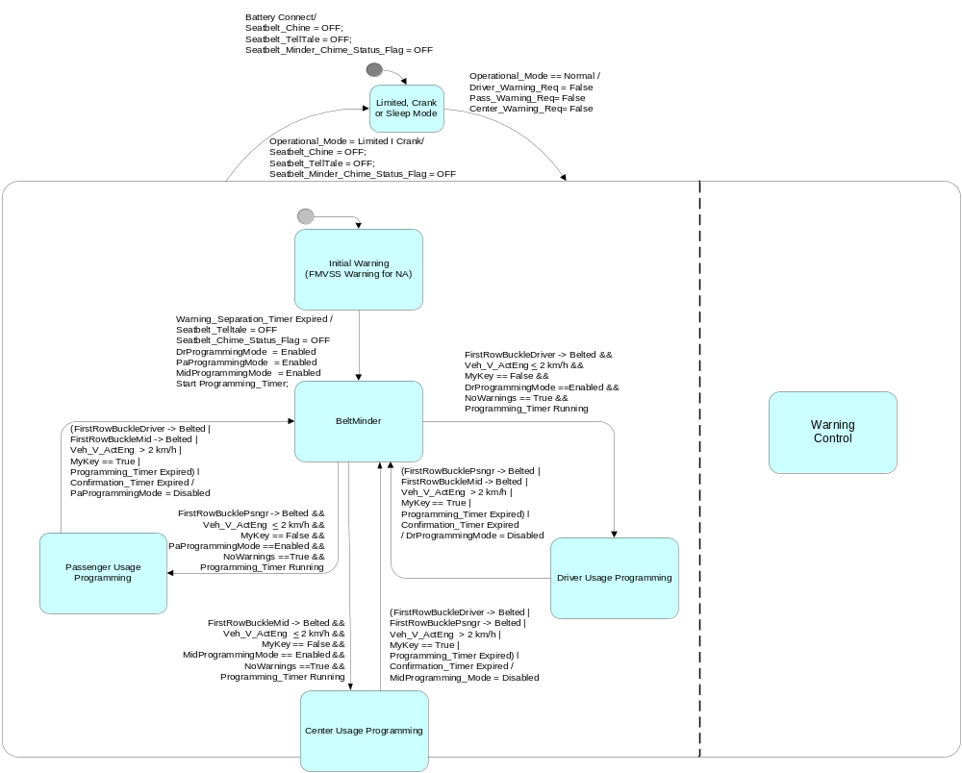

Initial (FMVSS) Warning

Note: If the cluster is not configured for Beltminder only the below diagram is applicable.
Figure 3 Initial (FMVSS) Seatbelt Warning Function Diagram
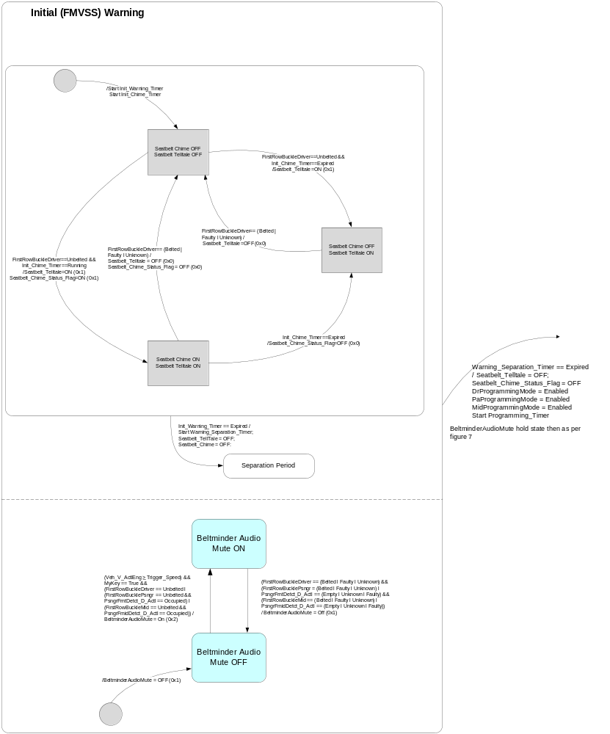

Beltminder Warning

Brief Description:
NOTE: NCAP requirements are now regulated as per ECE R16.

For North American Markets the Beltminder feature is a supplemental seatbelt warning that augments the FMVSS Seatbelt Warning function. For NCAP markets the beltminder feature is the primary seatbelt warning feature used to meet the NCAP warning requirements. This feature, when enabled, reminds the driver and/or passenger that their seatbelt(s) is unbuckled by illuminating the seatbelt warning lamp in the cluster and intermittently sounding a chime when the vehicle speed has exceeded 10km/h for North American Markets & 20 km/h for NCAP Markets .

North American Markets: The Beltminder feature is available after the initial (FMVSS) warning period is complete. When a BeltMinder warning is active, the seatbelt telltale flashes in sync to a chime for 6 seconds then the seatbelt telltale is illuminated for 24 seconds without chime, turns off for 1s, then the cycle repeats' itself. If the vehicle speed drops below 5km/h, Beltminder warnings will suspend after completing the current active chime cycle, during suspend the seatbelt telltale shall remain illuminated. Once active, the feature shall continue to give warnings until all of the monitored belts are buckled, the IGN transitions to OFF or Accessory or START, or 270 seconds has elapsed since the first beltminder warning occurred.

The initial BeltMinder warning if warranted (unbuckled driver, passenger, or middle passenger), will be provided after the FMVSS period has expired and vehicle speed is above 10km/h. Upon all beltminder occupants becoming buckled a subsequent unbuckle by one of the beltminder eligible occupants shall re-enable the beltminder warning at any time through the remainder of the key-cycle. These subsequent warnings throughout the key-cycle are termed “Tollbooth” BeltMinder warnings and use a delay timer to allow the occupant to briefly unbuckle then re-buckle for certain events like paying a tool. For MyKey applications this delay timer is reduced to 9.5s.

ECE Reg 16/NCAP Markets (FoE Seatelt Warn Strat Config bit set to enabled): The initial warning period (FMVSS) timer is reduced to 5s so the system jumps directly to the beltminder warnings after lighting the seatbelt telltale for 5s. Upon transition to Normal/Crank the Seatbelt telltale illuminates for 5s then turns off until the first beltminder event occurs. Vehicle speed must exceed 20km/h for the beltminder warning to initially sound. If 20km/h is achieved at 5s the system could transition directly into the first beltminder event from the initial warning period. Subsequent re-triggering of the beltminder feature shall occur at 10 km/h. For NCAP markets the seatbelt telltale flashes in sync to a chime for 6 seconds then illuminates solid for 8.5 seconds, turns off for 1s, then the cycle repeats itself. For ECE Reg 16 / NCAP markets the Suspend_Speed variable is set to zero to disable the suspend feature. The tollbooth delay timer is also reduced to 0 seconds for NCAP applications.

For both North American and NCAP markets, if in reverse the beltminder feature is suspended. Shifting out of reverse will reset the beltminder warning timer to 270 seconds for any active seating position.

Passenger Beltminder warning shall be applied to the front row outside passenger and front row middle seat (if equipped). The passenger beltminder warnings will only be provided when an occupant/passenger is detected by the Occupant Classification system.

Figure 4 Beltminder – Driver Determination

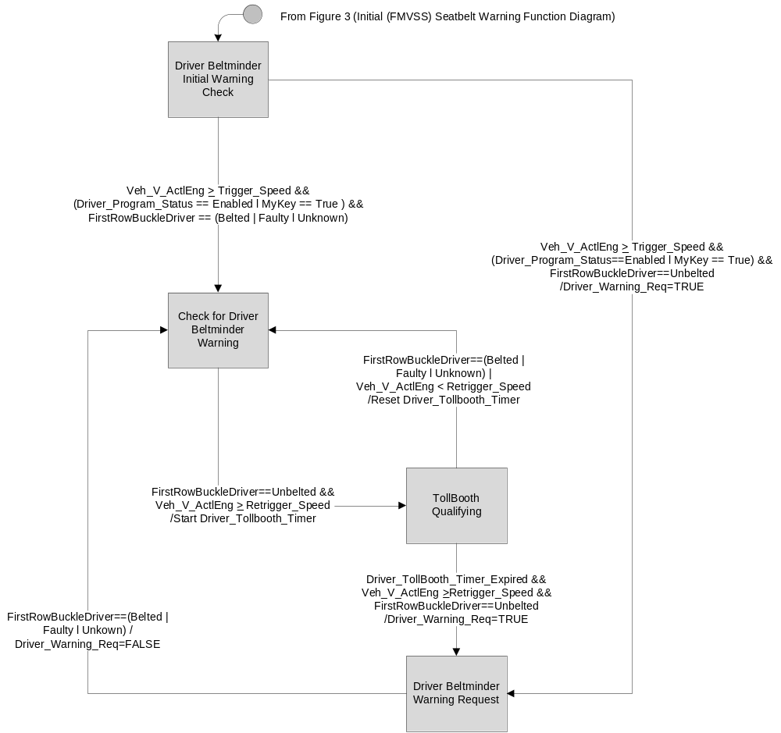
Figure 5 Beltminder – Passenger Determination

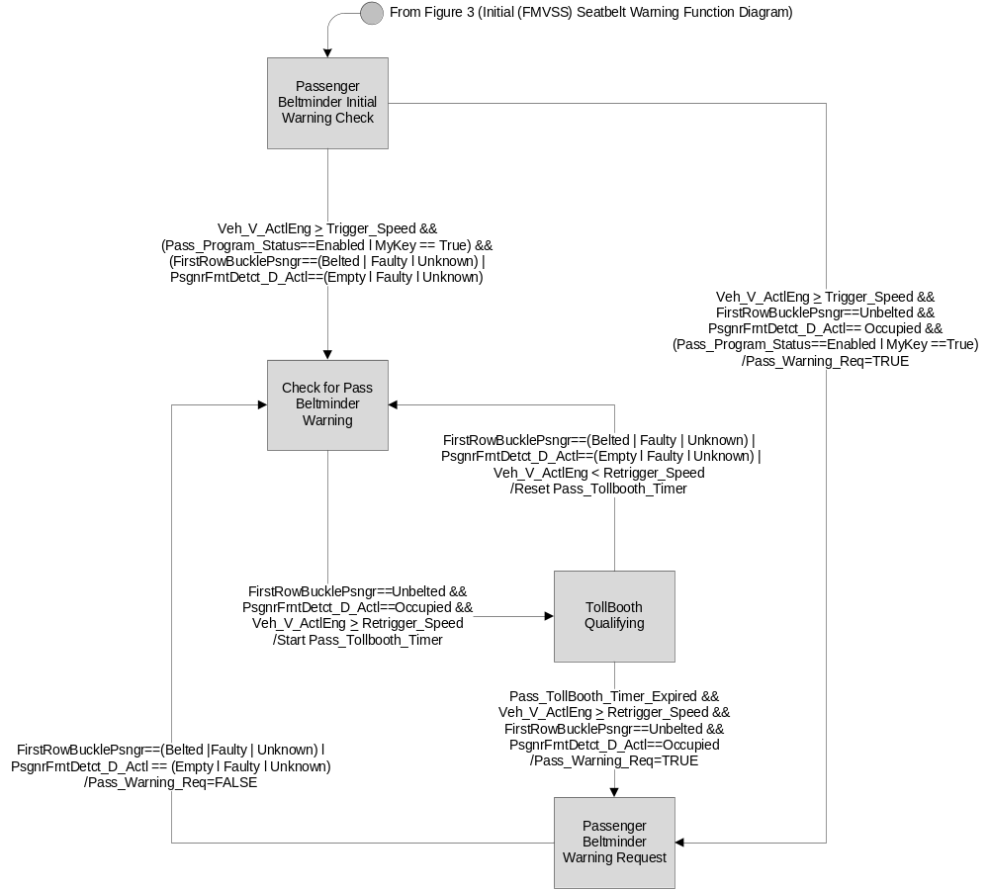

Figure 6 Beltminder – Front Middle Passenger Determination
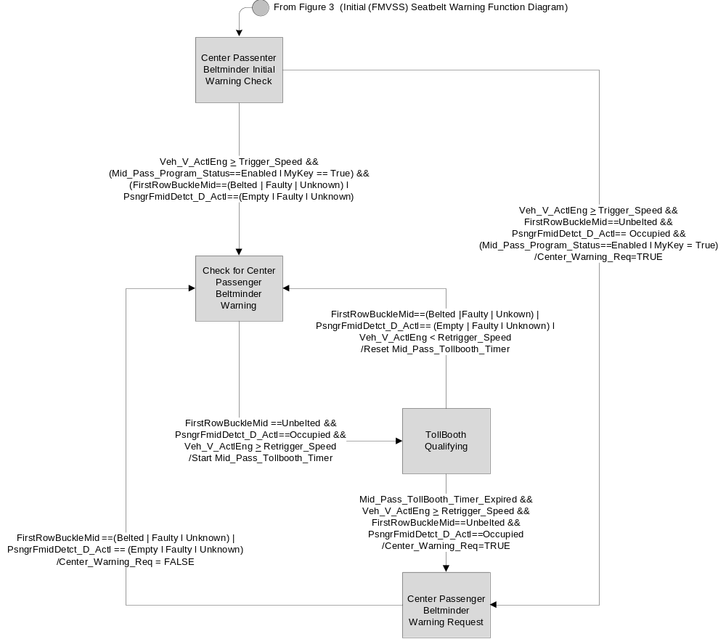
Figure 7 Beltminder Warning Control 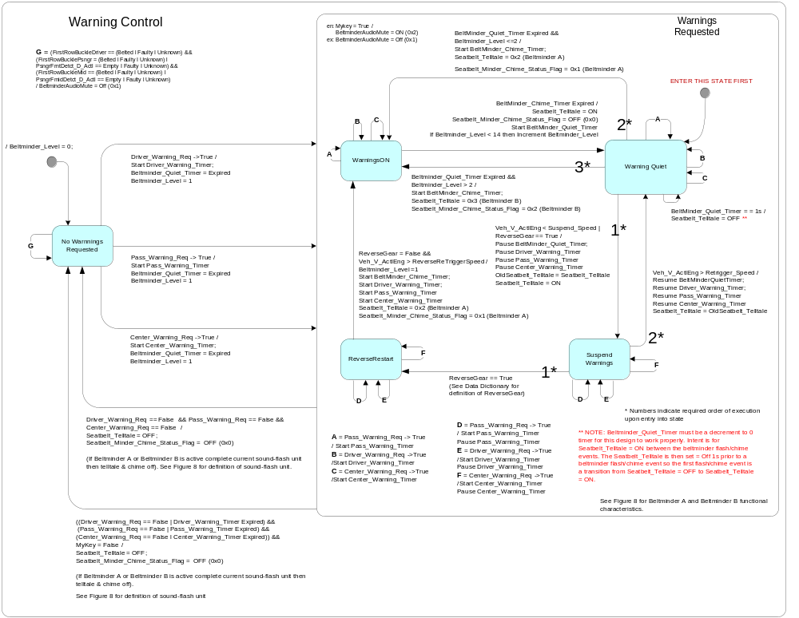

Figure 8 Beltminder Telltale Chime Function

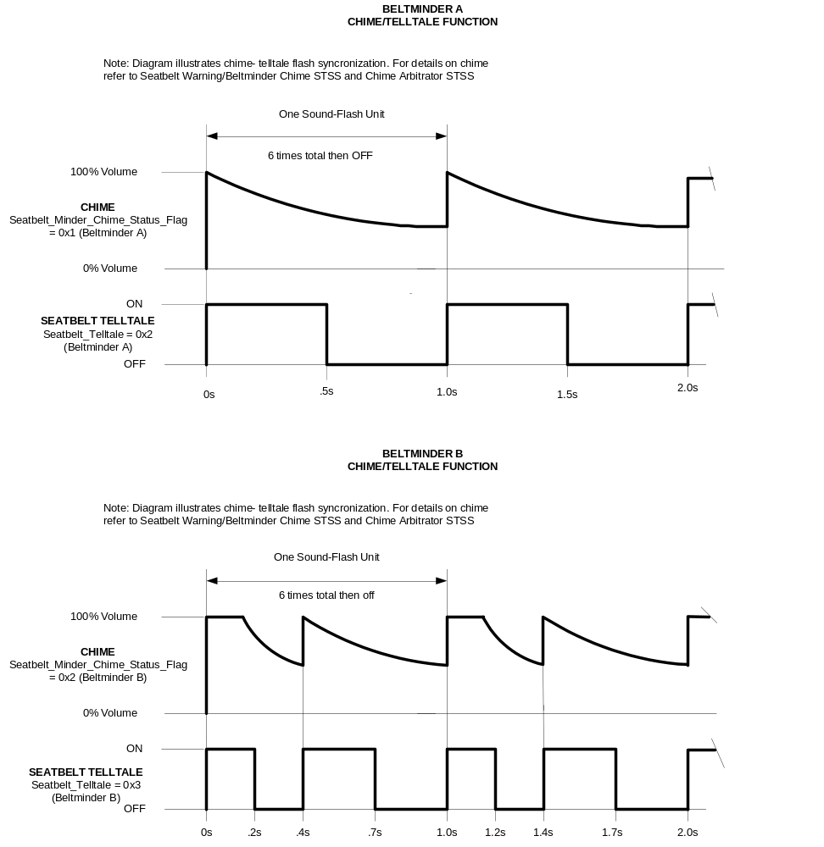

Beltminder Programming – Driver/Passenger

Overview:
Programming_Timer is started upon exiting Initial Warning (After completion of Init_Warning_Timer & Separation_Timer). It is also started upon successfully completing a seating position programming. This is to give the occupants another 30 seconds to program a second seating position. It is not started upon exit of a particular seat usage programming unless successful programming occurred. Only three restarts of the programming timer is allowed because one can only enter a seating position usage programming once per key cycle. The third restart of the timer is actually meaningless because at that time the other two xxProgrammingModes are disabled & the timer will just run until expired. Note once a seating positions programming usage is exited that seat position programming mode can never be re-entered that key cycle as it's ProgrammingMode is disabled.

Upon successful buckle / unbuckle programming of a seating position that seating positions Beltminder Config Bit is flipped to the opposite state. DID DE00 diagnostics may also change the state of any of the Beltminder Config Bits. This allows the customer if they cannot understand the programming procedure to take a vehicle into the dealership to have the Beltminder feature for that seating position or seating positions modified. The strategy also allows the customer to undue what was done at the dealership at some future point. New vehicle owner may understand the programming status and not want to have to pay a dealer for the programming process.

Figure 9 Driver Programming Diagram

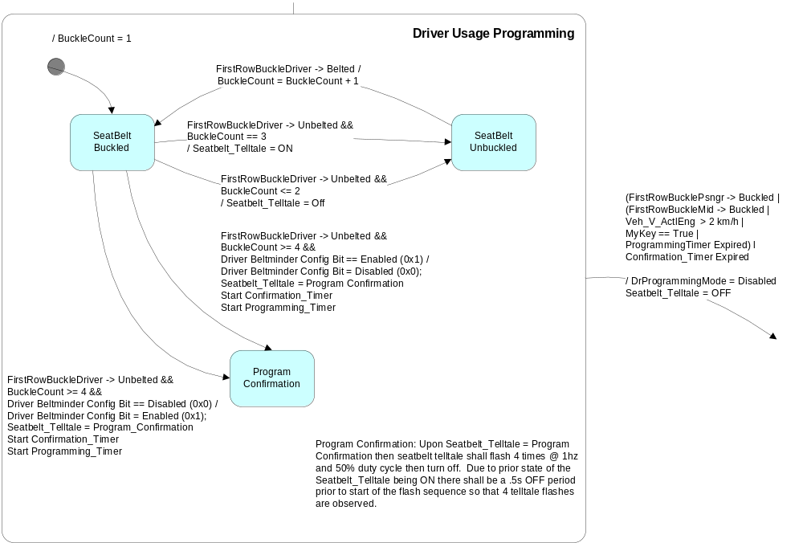

Figure 10 Passenger Programming Diagram 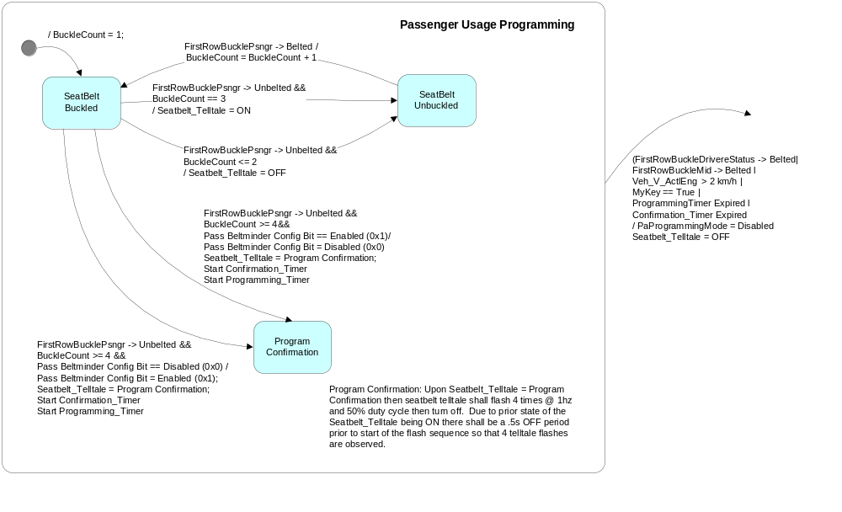
Figure 11 Front Middle Passenger Programming Diagram
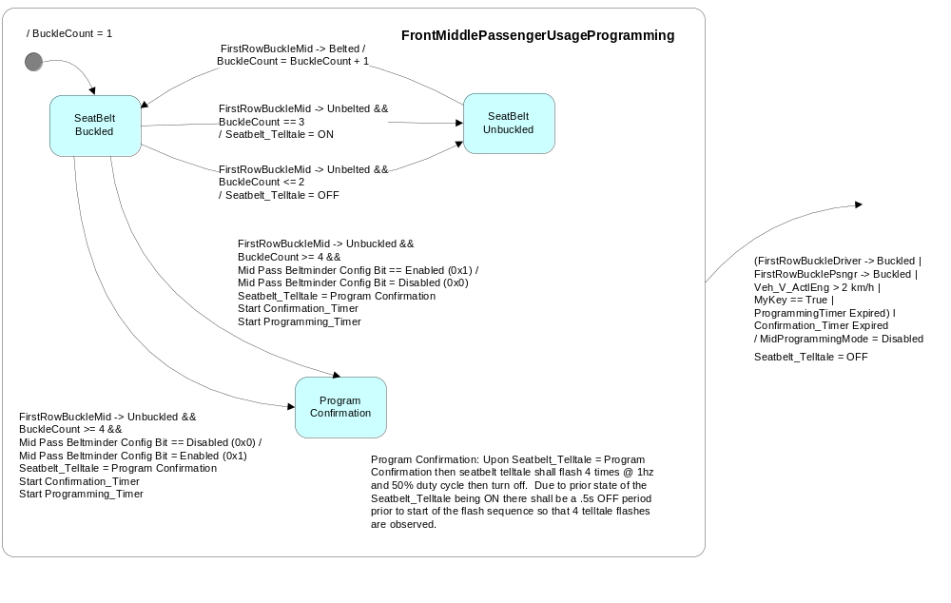

Diagnostic Operation

Operational_Mode | ETM_Bulb_Check_State | DIAG_SESSION_TIMER | Self_Test_Entry _Bulb  _Check_ Timer | DIAG_DID_  61A4,1,3  (Seatbelt) | DIAG_DID_  61A5,4,6  (all warning lamps) | Seatbelt_  Telltale
Normal or Crank | OFF (0x0) | Inactive | X | X | X | As per FC
Normal or Crank | ON (0x1) | Inactive | X | X | X | ON
Normal | OFF (0x0) | Active | Inactive | Not Received | Not Received | As per FC
Normal | ON (0x1) | Active | Inactive | Not Recieved | Not Recieved | ON
Normal | X | Active | X | ON (0x1) | X | ON
Normal | X | Active | X | X | ON (0x1) | ON
Normal | X | Active | Active | X | X | ON
All Other Cases |  |  |  |  |  | OFF

X = Don’t care
Not Received = The state when a DIAG_SESSION_TIMER is active and the DID has not been received

Operational_Mode | DIAG_SESSION_TIMER | DIAG_DID_6010,0,01 - Sounder Output  (Seat Belt Warning) | Seatbelt_Chime_Status_Flag | Seatbelt_Minder_Chime_  Status_Flag
Normal or Crank | Inactive | X | As per FC | As per FC
Normal | Active | Not Received | As per FC | As per FC
Normal | Active | ON (0x1) | True (0x1) | False (0x0)
Normal | Active | OFF (0x0) | False (0x0) | False (0x0)
Limited or Sleep | X | X | False (0x0) | False (0x0)

X = Don’t care
Not Received = The state when a DIAG_SESSION_TIMER is active and the DID has not been received

Operation Description (supports algorithm flowchart /state diagram)

- If it is established that a certain program will never have a front center seat then upon approval of the Ford Driver Information Applications engineer the front center seat beltminder logic need not be implemented.
- For Beltminder A and Beltminder B the seatbelt telltale shall FLASH in synchronization with the chime if the chime is available as determined by the chime arbitrator as per the Beltminder A and Beltminder B Chime/Telltale Characteristics diagrams above.
- If Beltminder A or Beltminder B chimes are not available due to a higher priority chime, the beltminder chimes shall not sound until the start of the next synchronized sound unit after the higher priority chime is completed.
    - Telltale defaults to OFF until inputs are received.
    - If when in Normal Mode DIAG_SESSION_TIMER is active and the telltale is ON due to a diagnostic command, it is acceptable to leave the telltale ON upon transition from Normal Mode to Crank Mode.
    - Driver_Program_Status, Pass_Program_Status, and Mid_Pass_Program_Status shall be stored in EEPROM so state is remembered for a battery disconnect.
    - Veh_V_ActlEng signal value shall be considered as valid data only when VehVActlEng_D_Qf has a value of (0x2) I (0x3). If VehVActlEng_D_Qf does not have a value of (0x2) I (0x3) then Veh_V_ActlEng signal value shall be considered equal to 0.

Table 1.10 Configurable Parameters
 | FoE Seatbelt Warn Strat Config Bit = Disabled (0x0)  (North America) | FoE Seatbelt Warn Strat Config Bit = Enabled (0x1)  (Europe & Other NCAP/ ECE16)
Beltminder_Quiet_Timer | 25s | 9.5s
Driver_Tollbooth_Timer: MyKey = = Standard Key  Driver_Tollbooth_Timer: MyKey = = True | 60s  10s | 0  0
Init_Warning_Timer | 65s | 5s
Warning_Separation_Timer | 2s | 0s
Init_Chime_Timer | 6.5s | 0
Pass_Tollbooth_Timer: MyKey = = Standard Key  Pass_Tollbooth_Timer: MyKey = = True | 60s  10s | 0  0
Suspend_Speed | 5 km/h | 0
Trigger_Speed | 10 km/h | 20 km/h
Retrigger_Speed | 10 km/h | 20 km/h
ReverseRetriggerSpeed | 10 km/h | 8 km/h
Mid_Pass_Tollbooth_Timer: MyKey = = Standard Key  Mid_Pass_Tollbooth_Timer: MyKey = = True | 60s  10s | 0  0

Table 1.11 Driver Program Status
Driver Beltminder Config Bit | Driver_Program_ Status
Disabled (0x0) | Disabled
Enabled (0x1) | Enabled

Table 1.12 Passenger Program Status
Pass Beltminder Config Bit | Pass_Program_Status
Disabled (0x0) | Disabled
Enabled (0x1) | Enabled

Table 1.13 Middle Passenger Program Status
Mid Pass Beltminder Config Bit | Mid_Pass_Program_Status
Disabled (0x0) | Disabled
Enabled (0x1) | Enabled

Function Safety Classification (EMC)

Class B

Memory Storage and Variable Definitions

Beltminder_Level:
Description: The level of consecutive BeltMinder warnings
Domain: ["0" | "1" | "2" | "3" | "4" | "5" | "6" | "7" | "8" | "9" | "10" | "11" | "12" | "13" | "14" ]
Initial State: "0"

BeltMinder_Chime_Timer:
Description: Timer running while Beltminder warnings are active and the chime is active
Domain: Between 1 and 6 seconds
Initial State: 6 seconds

BeltMinder_Quiet_Timer:
Description: Timer running while Beltminder warnings are active and the chime is OFF
Domain: Between 1 and 30 seconds
Initial Value: See Table 1.8

Buckle_Count:
Description: The number of buckle/unbuckle sequences detected during programming
Domain: ["1" | "2" | "3" | "4"]
Initial State: "1"

Center_Warning_Req
Description: Determination for the need of a Middle Passenger BeltMinder warning
Domain: True: A belt warning is needed
False: A belt warning is not needed
Initial State: False

Center_Warning_Timer
Description: Timer used to track the time the middle passenger has received continuous warnings
Domain: Between 1 and 270 seconds
Initial State: 270 seconds (4.5 minutes)

Driver_Program_Status
Description: Controls the decision to provide warnings based on the driver seatbelt status
Domain: Enabled: Do provide warnings based on the driver seatbelt status
Disabled: Do not provide warnings regardless of the status of the driver seatbelt
Initial State: Set as per value of DID DE00 Driver Beltminder Config Bit.

Driver_TollBooth_Timer
Description: Timer running for driver seat while Beltminder warnings are active and the Beltminder warning are OFF.

Domain: Between 1 and 60 seconds
Initial Value: 0, 10, or 60 seconds depending on market and MyKey status (See Table 1.8).

Driver_Warning_Req
Description: Determination for the need of a driver BeltMinder warning
Domain: True: A belt warning is needed
False: A belt warning is not needed
Initial State: False

Driver_Warning_Timer
Description: Timer used to track the time the driver has received continuous warnings
Domain: Between 1 and 270 seconds
Initial State: 270 seconds (4.5 minutes)

DrProgrammingMode
Description: Determination if BeltMinder programming is allowed for the driver seating position
Domain: Enabled: Programming is currently allowed
Disabled: Programming is currently not allowed
Initial State: Enabled

Init_Chime_Timer
Description: Timer running for the duration of the initial (FNVSS) seatbelt chime warning
Domain: Between 0, 6.5 seconds
Initial State: See Table 1.8

InitWarningTimer:
Description: Timer running for the duration of the initial (FNVSS) seatbelt seatbelt warning
Domain: Between 0 and 65 seconds
Initial State: See Table 1.8

Mid_Pass_Program_Status:
Description: Controls the decision to provide warnings based on the front middle passenger seatbelt status
Domain: Enabled: Do provide warnings based on the front middle passenger seatbelt status
Disabled: Do not provide warnings regardless of the status of the front middle passenger seatbelt
Initial State: Set as per value of DID DE00 Mid Pass Beltminder Config Bit.

Mid_Pass_TollBooth_Timer:
Description: Timer running for Middle Passenger seat while Beltminder warnings are active and the Beltminder warnings are OFF.
Domain: Between 1 and 60 seconds
Initial Value: 0, 10, or 60 seconds depending on market and MyKey status (See Table 1.8).

MidProgrammingMode
Description: Determination if BeltMinder programming is allowed for the front middle seat.
Domain: Enabled: Programming is currently allowed
Disabled: Programming is currently not allowed
Initial State: Enabled

MyKey
Description: If Current_Ign_Key_Dev_Type = = Key_In_Ign_My_Key then MyKey = True
If Current_Ign_Key_Dev_Type = = Key_In_Ign_Standard_Key l Unknown then MyKey = False
If the My Key feature is not present on the vehicle then MyKey = False
See MyKey Control Function section of this STSS for Current_Ign_Key_Dev_Type variable definition
Domain: True, False
Initial Value: False

NoWarnings:
Description: A logical combination of all Beltminder Warning Requests.
NoWarnings is True if Driver_Warn_Req == False and
Pass_Warn_Req == False and Center_Warn_req == False
otherwise NoWarnings is False.
Domain: [“True”, “False”]
Initial State: “True”

PaProgrammingMode
Description: Determination if BeltMinder programming is allowed for the passenger seating position
Domain: Enabled: Programming is currently allowed
Disabled: Programming is currently not allowed
Initial State: Enabled

Pass_Program_Status:
Description: Controls the decision to provide warnings based on the passenger seatbelt status
Domain: Enabled: Do provide warnings based on the passenger seatbelt status
Disabled: Do not provide warnings regardless of the status of the passenger seatbelt
Initial State: Set as per value of DID DE00 Pass Beltminder Config Bit.

Pass_TollBooth_Timer:
Description: Timer running for Passenger seat while Beltminder warnings are active and the Beltminder warning are OFF.
Domain: Between 1 and 60 seconds
Initial Value: 0, 10, or 60 seconds depending on market and MyKey status (See Table 1.8).

Pass_Warning_Req:
Description: Determination for the need of a passenger BeltMinder warning
Domain: True: A belt warning is needed
False: A belt warning is not needed
Initial State: False

Pass_Warning_Timer:
Description: Timer used to track the time the passenger has received continuous warnings
Domain: Between 1 and 270 seconds
Initial State: 270 seconds (4.5 minutes)

Programming_Timer
Description: Timer running for the duration that BeltMinder programming is allowed
Domain: Between 1 and 30 seconds
Initial State: 0 seconds

Retrigger Speed:
Description: Speed required to trigger a beltminder warning from "Check for xxxx Beltminder Warning" state.
Domain: Con. Value
Initial State: As per Table 1.8

ReverseGear:
Description: Status as to whether the vehicle is in reverse gear or not.
Domain: True: Vehicle is in Reverse Gear (determined as per table below)
False: Vehicle is not in Reverse Gear (determined as per table below)
Initial State: False

Operational_Mode | Transmission_Type_Cfg | GearLvrPos_D_Actl | GearRvrse_D_Actl | ReverseGear
Normal | Automatic (0x0) | Reverse (0x1) | X | True
Normal | Automatic (0x0) | Missing as per 1.4.1 | X | False
Normal | Manual (0x1) | X | Active_confirmed (0x3) | True
Normal | Manual (0x1) | X | Missing as per 1.4.1 | False
All Other Cases |  |  |  | False

Seatbelt_Chime_Status_Flag
Description: Status flag used by chime arbitrator to sound initial (FMVSS) chime.
Domain: ON: Initial (FMVSS) Chime ON
OFF: Initial (FMVSS) Chime OFF
Initial State: OFF

Seatbelt__Minder_Chime_Status_Flag
Description: Status flag used by chime arbitrator to sound Beltminder A or Beltminder B chime.
Domain: 0x0: OFF
0x1: Beltminder A
0x2: Beltminder B
Initial State: OFF

Seatbelt_Telltale
Description: Needed state of the seatbelt indicator telltale
Domain: ON (0x1): Seatbelt Telltale ON
OFF (0x0): Seatbelt Telltale OFF
BeltMinder A (0x2): Telltale flash sequence as per Figure 8.
BeltMinder B (0x3): Telltale flash sequence as per Figure 8.
Program Confirmation: Programming confirmation sequence (Flash 1 Hz @ 50% duty cycle) for 4 seconds
Initial State: OFF

Suspend _Speed
Description: Speed where below then Beltminder warnings are suspended (Current warning completes if active).
Domain: Con. Value
Con. Value Between 0 kph and 10kph depending on market (see Table 1.8)

Trigger_Speed
Description: Speed necessary to for beltminder warnings to be active.
Domain Con. Value
Con. Value Between 10kph and 25 kph depending on market (see Table 1.8)

Warning_ Separation _Timer
Description: Timer used to separate the FMVSS period from any BeltMinder warnings
Domain: Between 1 and 5 seconds
Initial State: See Table 1.10

Parameter Name | Description | Value at  Battery Connect | Value at  Module Wake-up | Value at Transition from Limited Mode to Normal l Crank
Seatbelt_Telltale | Internal cluster variable used to control and define the state of the LED. | 0x0 (OFF) | 0x0 (OFF) | As per Figure 2
Seatbelt_Chime_Status_Flag | Internal cluster flag used to control the FMVSS seatbelt chime. | 0x0 (OFF) | 0x0 (OFF) | As per Figure 2
Seatbelt_Minder_Chime_Status  _Flag | Internal cluster flag used to control the beltminder chime. | 0x0 (OFF) | 0x0 (OFF) | As per Figure 2
FirstRowBuckleDriver Signal | Signal to determine Driver buckle status | Belted (0x1) | Belted (0x1) | Belted (0x1)
FirstRowBucklePsngr Signal | Signal to determine Passenger buckle status | Belted (0x1) | Belted (0x1) | Belted (0x1)
FirstRowBucklwMid Signal | Signal to determine front row passenger middle status. | Belted (0x1) | Belted (0x1) | Belted (0x1)
PsngrFrntDetct_D_Actl Signal | Signal which identifies whether front row pass seat is Occupied or Empty. | Empty (0x0) | Empty (0x0) | Empty (0x0)
PsngrFmidDetct_D_Actl | Signal which identifies whether front row middle seat is Occupied or Empty. | Empty (0x0) | Empty (0x0) | Empty (0x0)
Veh_V_ActlEng Signal | Signal for vehicle speed | 0 | 0 | 0
VehVActlEng_D_Qf Signal | Quality factor for vehicle speed signal | (0x0) | (0x0) | (0x0)
GearLvrPos_D_Actl Signal | Used to inhibit Beltminder if in Reverse Gear | As per PRNDL section | As per PRNDL section | As per PRNDL section
BeltminderAudioMute | Output from cluster to tell the Audio to mute for MyKey application | 0x1 (Off) | 0x1 (Off) | 0x1 (Off)
Self_Test_Entry_Bulb_Check_ Timer | Timer used in diagnostic session to do a self check of telltales | Not Active | Not Active | Not Active
DIAG_SESSION_TIMER | Timer used to time-out a diagnostic session | Not Active | Not Active | Not Active
DIAG_DID_61A4,1,3 (Seatbelt) | Warning Lamp status 1, byte 1, bit 3 (Seatbelt) | 0 (0x0) | 0 (0x0) | 0 (0x0)
DIAG_DID_61A5,4,6 (all warning lamps) | Warning Lamp status 2, byte 4, bit 6 (all warning lamps) | 0 (0x0) | 0 (0x0) | 0 (0x0)
DIAG_DID_61B5,0,0F (Seat Belt Warning) | Sounder Output, parameter 0, state 0F (Seat Belt Warning) | 0 (0x0) | 0 (0x0) | 0 (0x0)
ETM_Bulb_Check_State | State indicator for warning bulb in ETM | OFF (0x0) | OFF (0x0) | OFF (0x0)
Operational_Mode | 4 state indicator for cluster operational mode | Limited | Limited, Normal or Crank | Limited, Normal or Crank

Prove Out

None

Error Handling

Missing Message Strategy
The signals will be declared missing as per the Diagnostics Section of this SPSS.

If any of the buckle status input signals are declared MISSING, those seating positions shall default to buckled.

If PsngrFrntDetct_D_Actl or PsngrFmidDetct_D_Actl signals are declared MISSING the appropriate signal shall default to Empty.

If Veh_V_ActlEng signal is declared missing default to 0.

The Seatbelt_Telltale, Seatbelt_Chime_Status_Flag and Seatbelt_Minder_Chime_Status_Flag shall indicate as per the state matrix within 100mS of receiving a valid message.

DTC states and history will be determined as per the Diagnostics Section of this SPSS.

Unknown Data

If FirstRowBuckleDriver is Unknown for greater than 5 seconds and Driver Beltminder Config bit is enabled, then the cluster shall log DTC C45281.

If FirstRowBucklePsngr is Unknown for greater than 5 seconds and Pass Beltminder Config bit is enabled, then the cluster shall log DTC C45281.

If FirstRowBuckleMid is Unknown for greater than 5 seconds and Mid Pass Beltminder Config bit is enabled, then the cluster shall log DTC C45281.

Diagnostics

Self Test

Bulb illuminated during self test as per Self_Entry_Bulb_Check_Timer

Engineering Test Mode

Reference section “Dealer / Engineering Test Mode (ETM)”

Part II Performance

Supported Diagnostic DIDs
Number | DID / CommonID Name | DID Type
61A4 | Warning Lamp status 1, byte 1, bit 3 (Seatbelt) | Bit Mapped
61A5 | Warning Lamp status 2, byte 4, bit 6 (all warning lamps) | Bit Mapped
61B5 | Sounder Output, parameter 0, state 0F (Seat Belt Warning) | State Encoded

Supported Diagnostic Trouble Codes (DTCs)

DTC | Description | When Logged
C15187 | Lost Communication with Restraints Control Module | Message missing for more than 5 seconds and configuration enabled.
C42581 | Unknown Data received from Restraints Control Module. | Unknown signal value received for more than 5 seconds and configuration enabled. (see 1.4.2)

DID DE00
Block  Num | Block Description | Size (bits) | Type | Byte(s) | Bits | State: Description | "0" | "1" | Default | Comments/  Information
PACKETED BLOCKS
 | Option Content (B&A) | 32 | 1 |  |  | Driver Beltminder | Disabled | Enabled | Enabled
 | Option Content (B&A) | 32 | 1 |  |  | Pass BeltMinder | Disabled | Enabled | Enabled
 | Option Content (B&A) | 32 | 1 |  |  | Mid Pass Beltminder | Disabled | Enabled | Enabled
$00 | Option Content (B&A) | 32 | 1 | * | * | FoE Seatbelt Warn Strat | Disabled | Enabled | Disabled | Enabled for markets required to meet NCAP / ECE 16
*Byte and bit location to be identified in Part II Specification for this cluster
Note: Driver Beltminder, Pass Beltminder, and Mid Pass Beltminder config bits may also be toggled as per Beltminder Programming Driver / Passenger section (1.3.5.1.4).

Block  Num | Block Description | Byte(s) | Bits | State: Description | "0" | "1" | Default | Comments/ Information
PACKETED BLOCKS
$00 | Option Content (B&A) | * | * | Transmission Type | Automatic | Manual | 0 (Automatic)
 | *Byte and bit location to be identified in Part II Specification for this cluster

Reference Specification
Global Seatbelt Warning Specification v20.1

SY-0094 Restraint Prim. Fault Ind.
SY-0046 Status Ind. Visibility

IS-0001 WARNINGS/INDICATORS/DISPLAYS PROVEOUT
IS-0046 INSTRUMENTATION MATERIAL RESISTANCE TO CLEANING
IS-0052 OPERATING VOLTAGES - FUNCTIONAL/PERFORMANCE
IS-0069 FUNCTIONAL IMPORTANCE CLASS
IS-0324 WINDSHIELD & OTHER REFLECTIONS
IS-0327 WARNING INDICATOR EVALUATION
IS-0329 FLICKERING OF LAMPS
IS-0379 NORTH AMERICAN WARNINGS AND INDICATORS STRATEGY

IL-0017 TELLTALE AND INTERIOR ILLUMINATION COLOR
IL-0021 CRAFTSMANSHIP - DISPLAYS
IL-0023 CLARITY/LEGIBILITY/READABILITY
IL-0025 INTERIOR ILLUMINATION INTENSITY
IL -0027 VISUAL CONTRAST
IL -0043 OPERATIONAL ENVIRONMENT FUNCTIONALITY
IL -0045 COLOR
IL -0047 TELLTALE; INDICATOR AND DISPLAY LIGHT INTENSITY
IL -0048 ILLUMINATION ACCEPTABILITY
03-0661 PLACEMENT: CONTROL AND DISPLAY LOCATIONS
03-0662 PLACEMENT: LOGICAL GROUPING FUNCTION AND USAGE
03-0664 PLACEMENT: DOWN VISION TO COMPONENTS WITH HIGH VISUAL DEMAND
03-0665 PLACEMENT: EXPECTED LOCATIONS OF CONTROLS AND DISPLAYS VDS
03-0670 INTERIOR VISIBILITY
03-0671 INTERIOR VISIBILITY: REFLECTIONS FROM COMPONENTS & SURFACES
03-0672 INTERIOR VISIBILITY: REFLECTIONS IN DISPLAYS
03-0673 INTERIOR VISIBILITY: VISUAL OBSCURATIONS
03-0674 INTERIOR VISIBILITY: ILLUMINATION CONTROLS / DISPLAYS
03-0675 INTERIOR VISIBILITY: VEILING GLARE
03-0677 INTERIOR VISIBILITY: SUNLIGHT WASHOUT
03-0681 IDENTIFICATION: CHARACTER AND SYMBOL SIZE
03-0682 IDENTIFICATION: LEGIBILITY
03-0685 IDENTIFICATION: SYMBOLS, ABBREV FOR CONTROL
03-0721 LOGIC OF OPERATION: OPERATIONAL STEREOTYPES
03-0722 LOGIC OF OPERATION: INTERPRETATION
03-0723 LOGIC OF OPERATION: USE OF SYSTEMS WITH VISUAL DISPLAYS

Revision History

SPSS Module Revision History

Revision Level | Name | Change Description | Date
1.0 | JBlatchf | Initial Release | 10/19/2010
2.0 | JBlatchf | Tables 1.0 – 1.5 changed description of signal value 0x3 to match CMDB.  1.2.2: Added RBM_FoE_Cfg to list of inputs.  1.3.5.1: Deleted MyKey variable definition and moved it to 1.3.5.4  Figure 4: Corrected typo speed signal.  Figures 4,5, & 6: Added gear position (not reverse) as a condition for exiting Initial Warning Check state.  1.3.5.2: Added note relative to implementation of front center seat. Added note relative to EPROM  Figure 10: Added then statement inadvertently omitted.  Table 1.8: Modified Init_Warning_Timer, Warning_Separation_Timer, & Trigger Speed to insure new ECE regulation is met.  1.3.5.4: Added MyKey variable. Description (moved from 1.3.5.1)  Driver_Program_Status, Pass_Program_Status, and Mid_Pass_Program_Status: Added EEPROM & initial manufacturing plant state.  Added column to memory storage table as per prior change to CGEA 1.1/1.2 version. | 11/22/2010
3.0 | Jblatchf | Change required to insure Beltminder function meets NCAP and ECE16 regulation.  - Updated last paragraph.  Table 1.9: Updated with new signal.  Figure 2: Updated 3 km/h to 2 km/h throughout. Added separate Dr, Pa, & Mid Programming Modes.  Figure 3: Added Faulty l Unknown to statements as appropriate. Updated to BeltminderAudioMute signal, added MyKey as condition, added Dr, Pa, & Mid Programming modes.  1.3.5.1.3 Updated description.  Figures 4, 5, & 6: Removed Reverse Gear signal, added Faulty l Unknown to conditions as appropriate, added Retrigger_Speed variable as appropriate.  Figure 7: Significant modification.  1.3.5.1.4 Remove beltminder disable description.  Figure 9, 10, &11: Updated to new programming strategy.  Table 1.8: Changed Beltminder_Quiet_Timer value to meet certain export market requirements.  Data Dictionary: Added DrProgrammingMode, PaProgrammingMode, MidProgrammingMode, and Retrigger_Speed variables. | 3/7/2011
4.0 | Jblatchf | 1.1: Updated last paragraph (4s change to 5s).  Figure 1 – Corrected signal output.  1.3.5.1.3: Corrected "NCAP Markets:" paragraph. 4s change to 5s.  1.3.5.1.4: Added overview upon request from supplier.  Figure 4, 5, & 6: Added enter from note to clarify. Figure 5 & 6 added  Faulty l Unknown to flow from Initial Check to Check for Warning.  Figure 9, 10, 11: Replaced xxx_Program_Status with xxx Beltminder Config Bit  1.3.5.2: Added note relative to Qf signals.  Table 1.11, 1.12, 1.13: Added Tables  1.4.2: Added DTC for Unknown buckle values.  1.5.3: Added DTC, Modified DID DE00 table & added note below table. | 4/6/2011
5.0 | Jblatchf | Updated based on late direction to insure Euro NCAP requirements are met. Direction as per Mantik, Reiner (R.) email 6/22/2011. Additional minor corrections incorporated.  Figure 2: Removed Beltminder_Cfg in transition from Initial Warning to Beltminder.  Figure 7: Renamed Lower left state to ReversRestart (no impact on function). Changed Trigger_Speed variable to ReverseRetriggerSpeed (Reverse Restart to WanringsOn path only). Removed not needed && in path from Suspend Warnings to Warning Quiet. Added * to all numbers in order of operation.  Table1.10: Changed Warning_Separation_Timer values. Added ReverseRetriggerSpeed variable. Changed FoE Retrigger_Speed. | 6/28/2011
5.1 | Jblatchf | This change sets MyKey = False when the key type is unknown. This prevents the possibility of a muted radio due to MyKey while in RUN from continuing upon a transition in ACC.  1.1: Updated description to help clarify.  Figure 2: Transition out of "Belted" state changed < to < to match Global Seatbelt Specification.  Figure 3: Transition out of "Beltminder Audio Mute Off" modified > to > to match Global Seatbelt Specification.  1.3.5.1.3: Updated Brief Description for clarification.  1.3.5.4: MyKey modified. (page 19 of 26). | 9/26/2011
5.2 | Jblatchf | This is minor change to clarify for supplier.  1.3.5.1.3 Brief Descripiton – Modified slightly.  Figure 4,5,6: Changed > sign to > (Veh_V_ActlEng > Retrigger_Speed)  Figure 7: Added ** Note:  Figure 9, 10, 11: Updated Program Confirmation Note. | 10/21/2011
6.0 | Jblatchf | It was identified that for FoE NCAP markets the suspend feature is disabled. To achieve this Suspend_Speed variable revised from 2 km/h to zero.  1.3.5.1.3 Brief Description: Updated to reflect expectedbehavior.  Table 1.10: Update Suspend ThresholdSpeed to correct vairable name. Change  Suspend_Speed variable FoE ….Config value from 2 km/h to 0.  1.3.5.4: Corrected Warning_Separation_Timer variable Initial State to refer to separate  table instead of using hard value. (unrelated typo correction). | 1/27/2012
7.0 | Jblatchf | Intent of this revision is to change the operational modes of this feature from Normal or Crank to Normal mode only. This is to address the fact that audio based chimes are not able to function in Crank mode. Due to that up to 2s of the FMVSS seatbelt chime may be lost due to operator Crank. Other minor typo’s and changes to reflect as manufactured.  - 1.3.1: Changed table - Crank Mode to OFF.  - Figure 2: Modified to turn feature off upon entry into Limited or Crank modes.  Modified to turn feature on only if in Normal mode. Modified “Limited or Sleep Mode” state to “Limited, Crank, or Sleep Mode”. Added Crank to path into Limited, Crank, or Sleep Mode state. Removed Crank from path out of Limited, Crank Mode state.  - Transitional table on page 21: Modified first three rows value at transition from Limited to Normal or Crank.  Changes to reflect as manufactured:  - Figure 7: Path from ReverseRestart to WarningsON – Changed Beltminder B to Beltminder A to match numeric value and as manufactured. Added Faulty I Unknown to PsngFmidDetct_D_Actl & PsngrFrntDetct_D_Actl as is typical throughout document.  - 1.3.5.2: Modified Qf statement so for both values (0x2) or (0x3) speed signal is considered valid.  - 1.3.5.4: Beltminder_Quiet_Timer, Init_Chime_Timer, and InitWarningTimer, removed actual values for Initial State as it is duplicate information to  Table 1.8. | 6/28/2012
8.0 | Jblatchf | This change prevents entry into Beltminder Programing mode if either the Driver_Warn_Req, Pass_Warn_Req, or Center_Warn_Req are True. It is required to insure NCAP requirements are met when FoE Seatbelt Warn Strat configuration is set to enabled.  - Figure 2: Added NoWarnings == True as a condition to enter any programming mode.  - 1.3.5.4: Added NoWarnings to variables definition.  - Table 1.10: Unrelated change corrected to Pass_Tollbooth_Timer and Mid_Pass_Tollboth timer.  - 1.3.5.1.3: Changed 25 km/h to 20 km/h in paragraph 1. Added Start to description in second paragraph. | 9/28/12
9.0 | Jblatchf | Intent of this change is to add appropriate reverse gear signal for manual transmission vehicles.  - 1.1: Added new GearRvrse_D_Actl signal to description.  - Figure 1: Added Transmission Type configuration, added signal.  - Added Table 1.8 renumbered tables to correct omission of Table 1.4.  - Figure 7: Changed GearLvlPos_D_Actl signal to ReverseGear variable throughout. Changed unrelated typo in path out of ReverseRestart – Seatbelt_Minder_Chime_Status_Flag changed from 0x2 to 0x1 to properly match Beltminder A as called out.  - 1.3.5.4: Added ReverseGear variable and states definition.  - 1.4.1: Removed statement relateive to GearLvrPos_D_Actl. See 1.3.5.4.  - 1.5.3: Added Transmission Type configuration table. | 12/4/12
9.1 | Jblatchf | Due to delays in audio system unmuting in certain applications the final (4th) initial chime is being cut off. This change extends the Init_Chime_Timer to 6.5s max to insure all of the initial chimes are sounded. For Lincoln chime applications the Chime Arbitrator Seatbelt chime must be changed from 4 to 3 chimes total or for Lincoln applications 4 chimes will sound instead of the 3 chimes as is design intent. This change approved for STSS development in the 9/18/2014 DI Change Control meeting.  - Table 1.10: Changed timer duration from 6.0s to 6.5s.  - 1.3.5.4: Updated max value from 6.0s to 6.5s. | 9/18/2014
1.0 | Jblatchf | Initial release from Seatbelt / Beltminder Telltale – IPC Controlled CGEA1.3v 9.1. This is program specific STSS release to disable the buckle/unbuckle beltminder disable feature for reasons as described in the functional description.  1.1: Functional Description: Added paragraph describing nature of this change.  1.3.5.4: Updated memory storage to change Programming_Timer from 30s to 0s. | 11/05/2014

